Ordering an eBook from OASIS using the Real Time Ordering (RTO) | 

Yoel Kortick
Senior Librarian

Question:
Can eBooks be ordered from OASIS using the Real Time Ordering (RTO) integration with Alma

Answer:
Yes, eBooks van be ordered from OASIS using the Real Time Ordering (RTO) integration with Alma

ONE
Log into OASIS at https://oasis.proquest.com

TWO
Search for an eBook such as title “Power Electronics in Renewable Energy Systems and Smart Grid: Technology and Applications” ISBN 9781119515661.

THREE
Select the record and click “Edit Order Info”

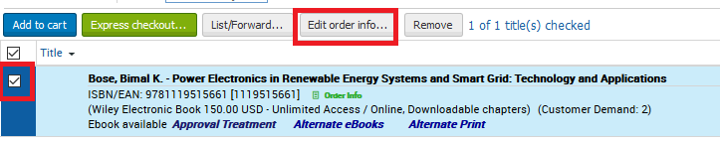

FOUR
In lower pane choose desired options such as selector, owner (library), quantity and fund. Click “save”

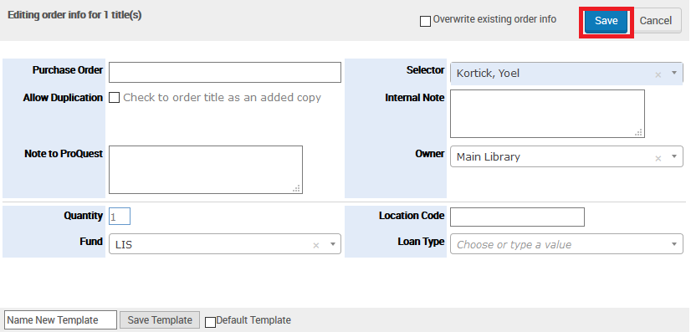

FIVE
In upper pane, with record selected, click “Express Checkout”

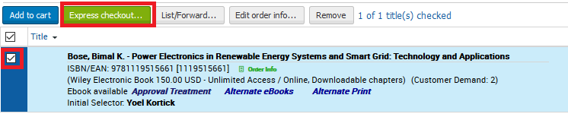

SIX
See that “Format Electronic” is selected and choose “Order All” and click “Submit All”

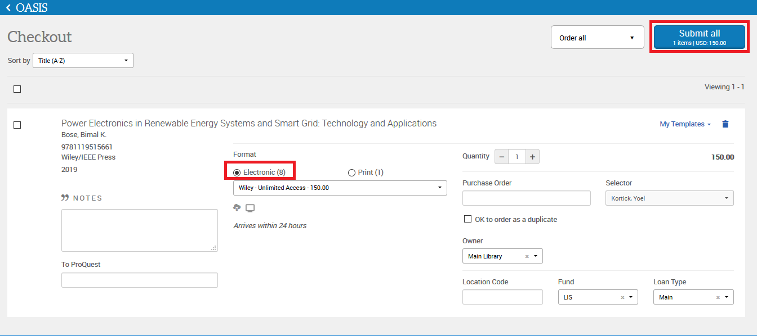

SEVEN
Check Alma and see that an order of type “Electronic Book - One Time” is created in Alma

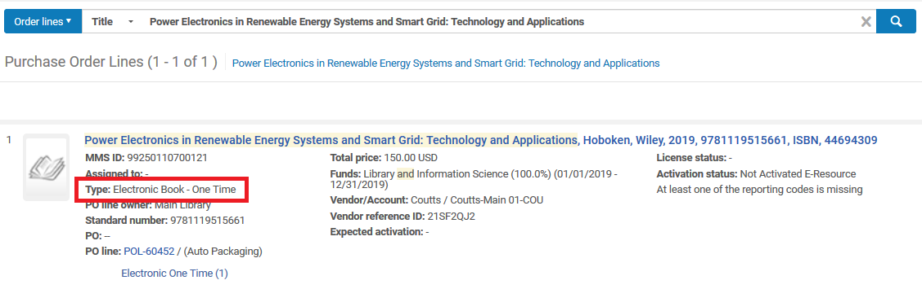

EIGHT
We see that the order was created from the API and has one non-active portfolio

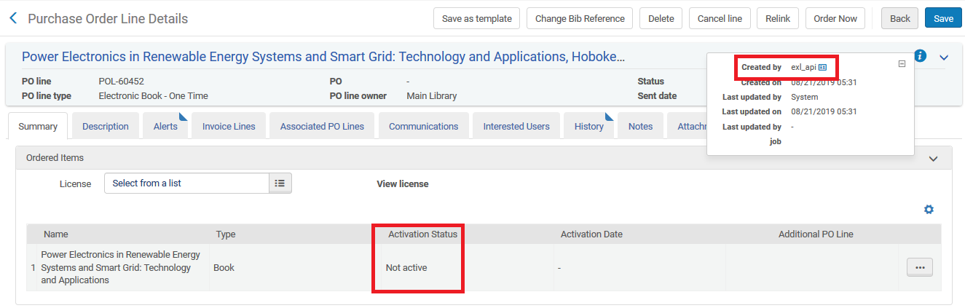

NINE
Here is the portfolio in a portfolio search

